www.artnc.org

Reading Art: Becoming Part of the Action
Writer: Carolyn Walker, English Language Arts Teacher
Grade Level: K–2
Related Big Picture Concept: Family
Subject Areas: Art, Language Arts, Theater Arts
Duration: 3–4 class sessions of 30–45 minutes. The first day will be shorter than the others.
Essential Question: How can we portray the idea of family in art?

Abstract: Students will improve visualization skills through role play, texture identification, and creating an original work of art depicting their own families. They will also discuss connections between the painting and their own lives. These activities will help them engage with the work of art and better understand what the artist is communicating about the family being portrayed.

Focus Works of Art:
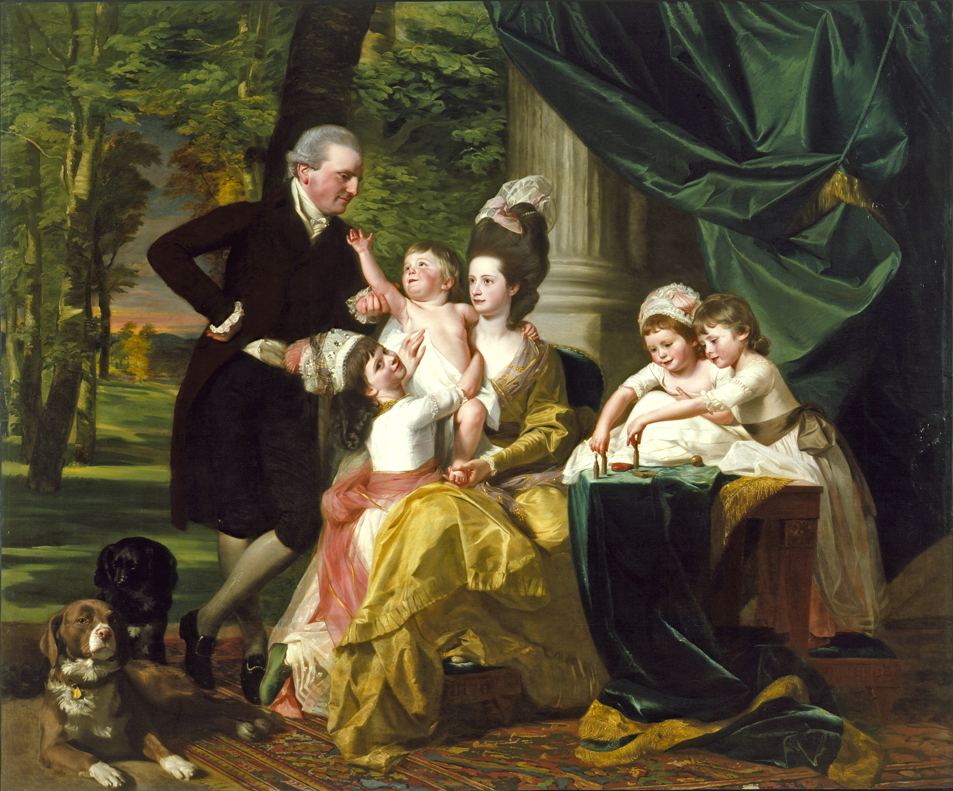
John Singleton Copley (American 1738-1815, active in Great Britain 1774-1815)
Sir William Pepperrell (1746-1816) and His Family, 1778
Oil on canvas
90 x 108 in. (228.6 x 274.3 cm)

North Carolina Standards Correlations
Visual Arts:
K.V.1.2, K.V.2.2, K.V.2.3, K.CX.1.1, K.CX.1.2
1.V.1.2, 1.V.1.3, 1.CX.1.2, 1.CX.1.3
2.V.1.2, 2.V.2.3

Language Arts:
K.W.7, K.W.8, K.SL.1
1.W.7, 1.W.8, 1.SL.1
2.W.7, 2.W.8, 2.SL.1

Theater Arts:
K.C.1.1, K.AE.1.2
1.C.1.1, 1.AE.1.2
2.C.1.1, 2.AE.1.2

Student Learning Objectives

- Students will create original art depicting families and discuss similarities and differences with the focus work.
- Students will recall information about the art to participate in a shared writing experience to express ideas about the focus work.
- Students will participate in collaborative conversations about families and the focus work.

Activities
Day 1
- Discuss the meaning of the term family today. What is a family? How is our class like a family? Ask students to bring a photograph of their family or those people who are important in their lives to school the next day.
- Show students Copley's painting of the Pepperrell family. Tell the students that the painting is a historical portrait of a family. Ask them to describe what they see.
  - Who are the people in the painting?
  - Where are they?
  - How are they dressed?
  - Do you think this was a real family? Why or why not?
  - How did the artist show the family?
  - Is this picture from now or long ago? How do you know? How might it look different if it were of a family today?
Tomorrow, you will have a chance to make your own portrait of your family.

Day 2
- Compare this portrait to the photographs that students brought from home. Have students share their experiences being photographed individually or as a family. Discuss the term portrait.

- Set up three learning stations around the room. Provide an 8 1/2 x 11" image of the painting and appropriate materials at each station. Students can rotate through the centers in small groups.

- Pose for the Camera:
Provide some props (toy dogs, drapery, tree, table, game, carpet, baby doll) and pieces of clothing (dresses, sashes, hats, man's suit) that are similar to those in Copley's painting. Instruct students to dress up and pose like the figures in the painting. Demonstrate how students are communicating nonverbally and discuss how costumes enhance the experience. Have an adult supervisor take a photo of the posing students with a disposable, Polaroid, or digital camera.

- Touch It:
Provide some pieces of fabric and small items that replicate the textures of the items in the painting, such as satin or silk, fur, marble, leaf or tree bark, and wool. Put these items in a bag. Instruct one student to reach into the bag and choose one item without looking at it or removing it from the bag. The student should use his or her best words to describe how this item feels. Instruct the other students in the group to identify an object in the painting that they think would feel the same as the item being described. Once a few students provide their responses, the student should take the object out of the touch bag and allow the other students to feel it. As a group, have the students reassess which item in the painting might feel the same way. Have an adult supervise this discussion.

- Family Portraits:
Using the Copley as inspiration, ask students to draw a picture of their own family or people who are important in their lives. Teacher demonstration will help. These drawings may include parents, siblings, pets, friends, etc. Provide white paper, colored pencils, markers, or crayons. Allow students to display their drawings on a blank wall using magnets, pushpins, or tape.

- Come back together as a class. Show students an image of the painting. Ask them to discuss what it felt like to dress up and pose like the family in the picture. Have them describe what they think the figures in the painting may be thinking or wanting to tell us (the viewers). Ask questions like:
If you could meet a member of the Pepperrell family, who would it be? Why?
What is a question you would like to ask that person?

Compare the wall of student art with the Pepperrell family. Discuss:
How is our work different from Mr. Copley’s work? (different materials, different subjects, long ago/now)
How are they similar?
How did the sensory station make you think about your art work and the Pepperrell family?

Day 3
- As a class, create a diamond poem about the Pepperrell family. Have students dictate a list of 10–15 words that come to mind when they look at the family in the painting, answering the question, “How do you describe the Pepperrell family?” Have them select their best words and create a diamond poem using the following form:

One word
Two words
Three words
Two words
One word

- Students in grades 1 and 2 can come together to brainstorm these words for a class list. You could give the students the poem model and ask them to write their own poem about the family using words from the list.

- Post these poems, the “pose for the camera” photographs, and family portraits drawings next to an image of the Pepperrell family. Discuss similarities and differences. Students could write in journals about what they notice.

Assessments
- Use class discussion, anecdotal records, and the drawing activity to determine students’ ability to make connections between their own lives and the family represented in the painting.

- Evaluate original art for students’ understanding of depicting ideas about people and portraits, using real sources of inspiration.

- Through discussion, evaluate how students recognize subjects, symbols, and themes in the works of others and how students compare the focus work with their own art and classmates’ art to show how artists express ideas differently in the past and present.

- Evaluate discussion using local rubrics for student participation, including following rules for discussion, building upon others’ ideas, and asking questions.

- Evaluate the poem using local rubrics for participating in shared writing and recalling information.

- Use the role play to assess the students' ability to assume a role and to recognize the role of costume, props, and setting to communicate meaning. Through discussion evaluate students’ understanding of the way they communicated nonverbally through costumes and posing for the pictures.

Resources

Vocabulary:
portrait

Materials:
Touch bag items (satin/silk, fur, marble, leaf/tree bark, wool)

Role-playing costumes (dresses, sashes, hats, man's suit) and props (toy dogs, drapery, tree, table, game, carpet, baby doll)

Disposable, Polaroid, or digital camera

Drawing materials (white paper, colored pencils, markers, or crayons)

Diamante worksheet

